CBSE ACCREDITATION DETAILS

CBSE ACCREDITATION DETAILS
1 | Name of the school with address:  (strictly as per Affiliation sanction letter or as permitted by the Board) with pin code no. | : | KENDRIYA VIDYALAYA RBNM SALBONI  PO: RBNML; DIST: MIDNAPORE (WEST)  PIN: 721132, WEST BENGAL
 | (i) E - mail | : | kvrbnmsalboni@yahoo.com
 | (ii) Ph. No. | : | 03227-280421
 | (iii) Fax No | : | --
2 | Year of establishment of school |  | 1998
3 | Whether NOC from state / UT or Recommendation of Embassy of India obtained? | : | N/A
 | (i) NOC No. | :
 | (ii) NOC issuing date | :
4 | Is the school is recognized, if yes by which Authority | : | KVS HQ, New Delhi under MHRD
5 | Status of affiliation |  | CBSE , New Delhi
 | Permanent / Regular / Provisional | : | Regular
 | (i) Affiliation no. | : | 2400050
 | (ii) Affiliation with the Board since | : | 1998
 | (iii) Extension of affiliation upto |  | 2025
6 | Name of Trust / Society / Company Registered under Section 25 of the Company Act, 1956. | : | KENDRIYA VIDYALAYA  SANGATHAN
 | Period upto which Registration of Trust / Society is valid | : | Permanent registration
7. | List of members of School Managing Committee | : | KENDRIYA VIDYALAYA RBNM, SALBONI  Vidyalaya Management Committee  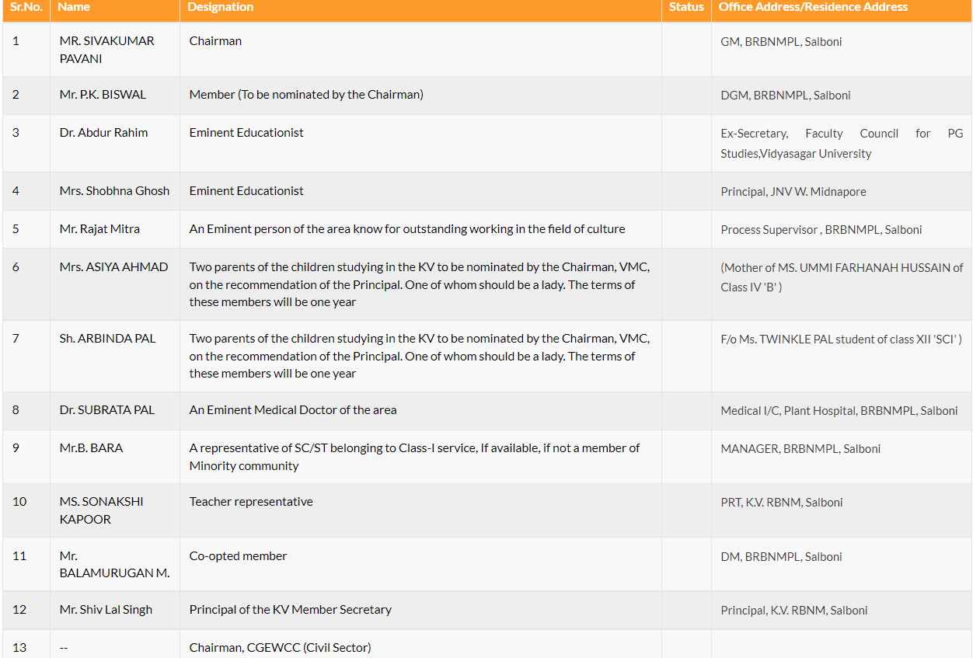
8. | Name of the Manager/President/Chairman/ Correspondent |  | Mr. SIVAKUMAR PAVANI  CGM, BRBNMPL, Salboni
9 | Area of school campus
 | (i) In Acres | : | .
 | (ii) In sq. mtrs. | : | 43140 Sq. mtrs.
 | (iii) Built up area (sq. mtrs) | : | .
 | (iv) Area of playground in sq. mtrs | : | 6000 sq. mtrs.
 | (v) Other facilities
 | (i) Swimming Pool | : | No
 | (ii) Indoor games | : | No
 | (iii) Dance Rooms | : | Yes
 | (iv) Gymansium |  | No
 | (v) Music Room | : | Yes
 | (vi) Hostels | : | No
 | (vii) Health and Medical check up | : | Yes
10 | Details of Fee (Monthly Total Fee) | : | 1. Admission Fee Rs. 25.00  2. Re Admission Fee Rs 100.00  3. Tutition Fee  3(a) Class IX & X (Boys) Rs 200.00  3(b) Class XI & XII Commerce & Humanities (Boys) Rs 300.00  3(c) Class XI & XII Science (Boys) Rs.400.00  4. Computer Fund  4(a) Class III onwards wherever Computer Education is being imparted Rs 100.00  4(b) Computer Science Fee. (for elective subjects) + 2 stage Rs 150.00  5 Vidyalaya Vikas Nidhi (Classes I - XII) Rs. 500.00
 | Pre-Nursery | : | --
 | Nursery | : | --
 | I-V | :
 | VI-VIII | :
 | IX & X | :
 | XI & XII | :
11 | Transport facility | :
 | (i) Own buses | : | N/A
 | (ii) Buses hired on contract basis | : | N/A
12 | Number of teaching staff (to be updated from time to time) | :
 | Principal | : | 01
 | Vice-Principal | : | 00
 | PGT | : | 09
 | TGT | : | 11
 | PRT | : | 09 including PRT(Music)
 | PRT( PET), TGT( PET), PGT(PET) | : | 01
 | Health Wellness Teacher | : | 01
 | Librarian | : | 01
 | Others | : | 03 (Non-teaching staff)
13 | Details of salary being paid by the School to teaching staff / non teaching Staff (to be updated time to time | :
 | Principal | : | Level-12 as per 7th CPC
 | Vice-Principal
 | PGT |  | Level-8 as per 7th CPC
 | TGT |  | Level-7 as per 7th CPC
 | PRT |  | Level-6 as per 7th CPC
 | PTI |  | Level-7 as per 7th CPC
 | Counsellor |  | --
 | Librarian |  | Level-8 as per 7th CPC
 | Others |  | SSA – Level-5, Sub –Staff 1- Level4, Sub –Staff 1- Level3
14 | Mode of payment of salary
 | (ii) Through single cheque transfer advice: |  | Released by KVS(HQ), New Delhi through UBI web portal
 | (iii) Individual cheque |  | --
 | (iv) Cash |  | --
15 | Library facilities
 | (i) Size of the library in sq. feet |  | 25x50 Sq. Ft.
 | (ii) No. of Periodicals |  | 30
 | (iii) No. of Dailies |  | 05
 | (iv) No. of Reference book class wise |  | 300 Each class IX to XII
 | (v)Â No. of Magazine |  | 1818
 | (vi) Others |  | 11290
16 | Name of the Grievance / redressal officer With E-mail, Ph. No., Fax No. : |  | Mr. SHIV LAL SINGH, Principal  kvrbnmsalboni@yahoo.com  03227-280421
17 | Members of Sexual Harassment Committee |  | MS. SONAKSHI KAPOOR, PRT
18 | Class wise enrolment for the current session |  | As on 30.06.2023

Class | No. Sections | Enrolment
Pre-Nursery | -- | --
Nursery | -- | --
I | 01 | 41
II | 01 | 44
III | 01 | 43
IV | 02 | 80
V | 02 | 79
VI | 01 | 46
VII | 01 | 43
VIII | 02 | 79
IX | 02 | 63
X | 02 | 57
XI | 02 | 46
XII | 02 | 41

19 | Academic session period | : | from April 2023 to March 2024
20 | Vacation period | : | Summer Vacation :  Autumn Break :  Winter Break :
21 | Admission period | : | from 10th Feb to 31st July every year

