**KENDRIYA VIDYALAYA, RBNM, SALBONI**

**Holiday Homework**

**CLASS 9TH**

**SUBJECT: SCIENCE (विज्ञान)**

**Name: _______________________________________ Date : __________________ Roll no_____________**

*Time allowed: 180 minutes Maximum Marks: 80*

General Instruction :

1. Question paper Contain **36 question** in three sections A , B and C.
2. **Section A** contain **1 marks** question from **1 to 20.**
3. **Section B** contain **3 marks** question form **21 to 30**.
4. **Section C** contain **5 marks** question form **31 to 30**.
5. Q 11 and Q 12 are assertion and reason type question. instruction are give at place of question in question paper.

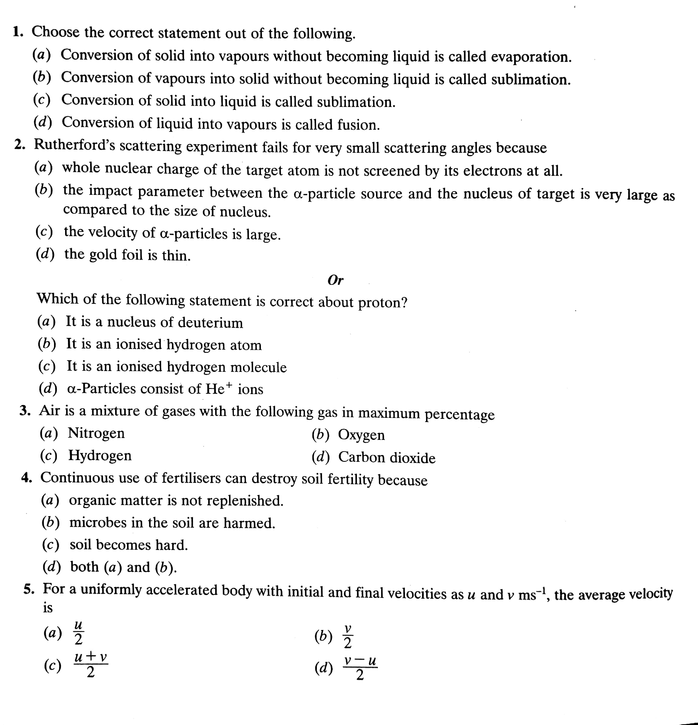**SECTION A [1 X 20 = 20 MARKS]**

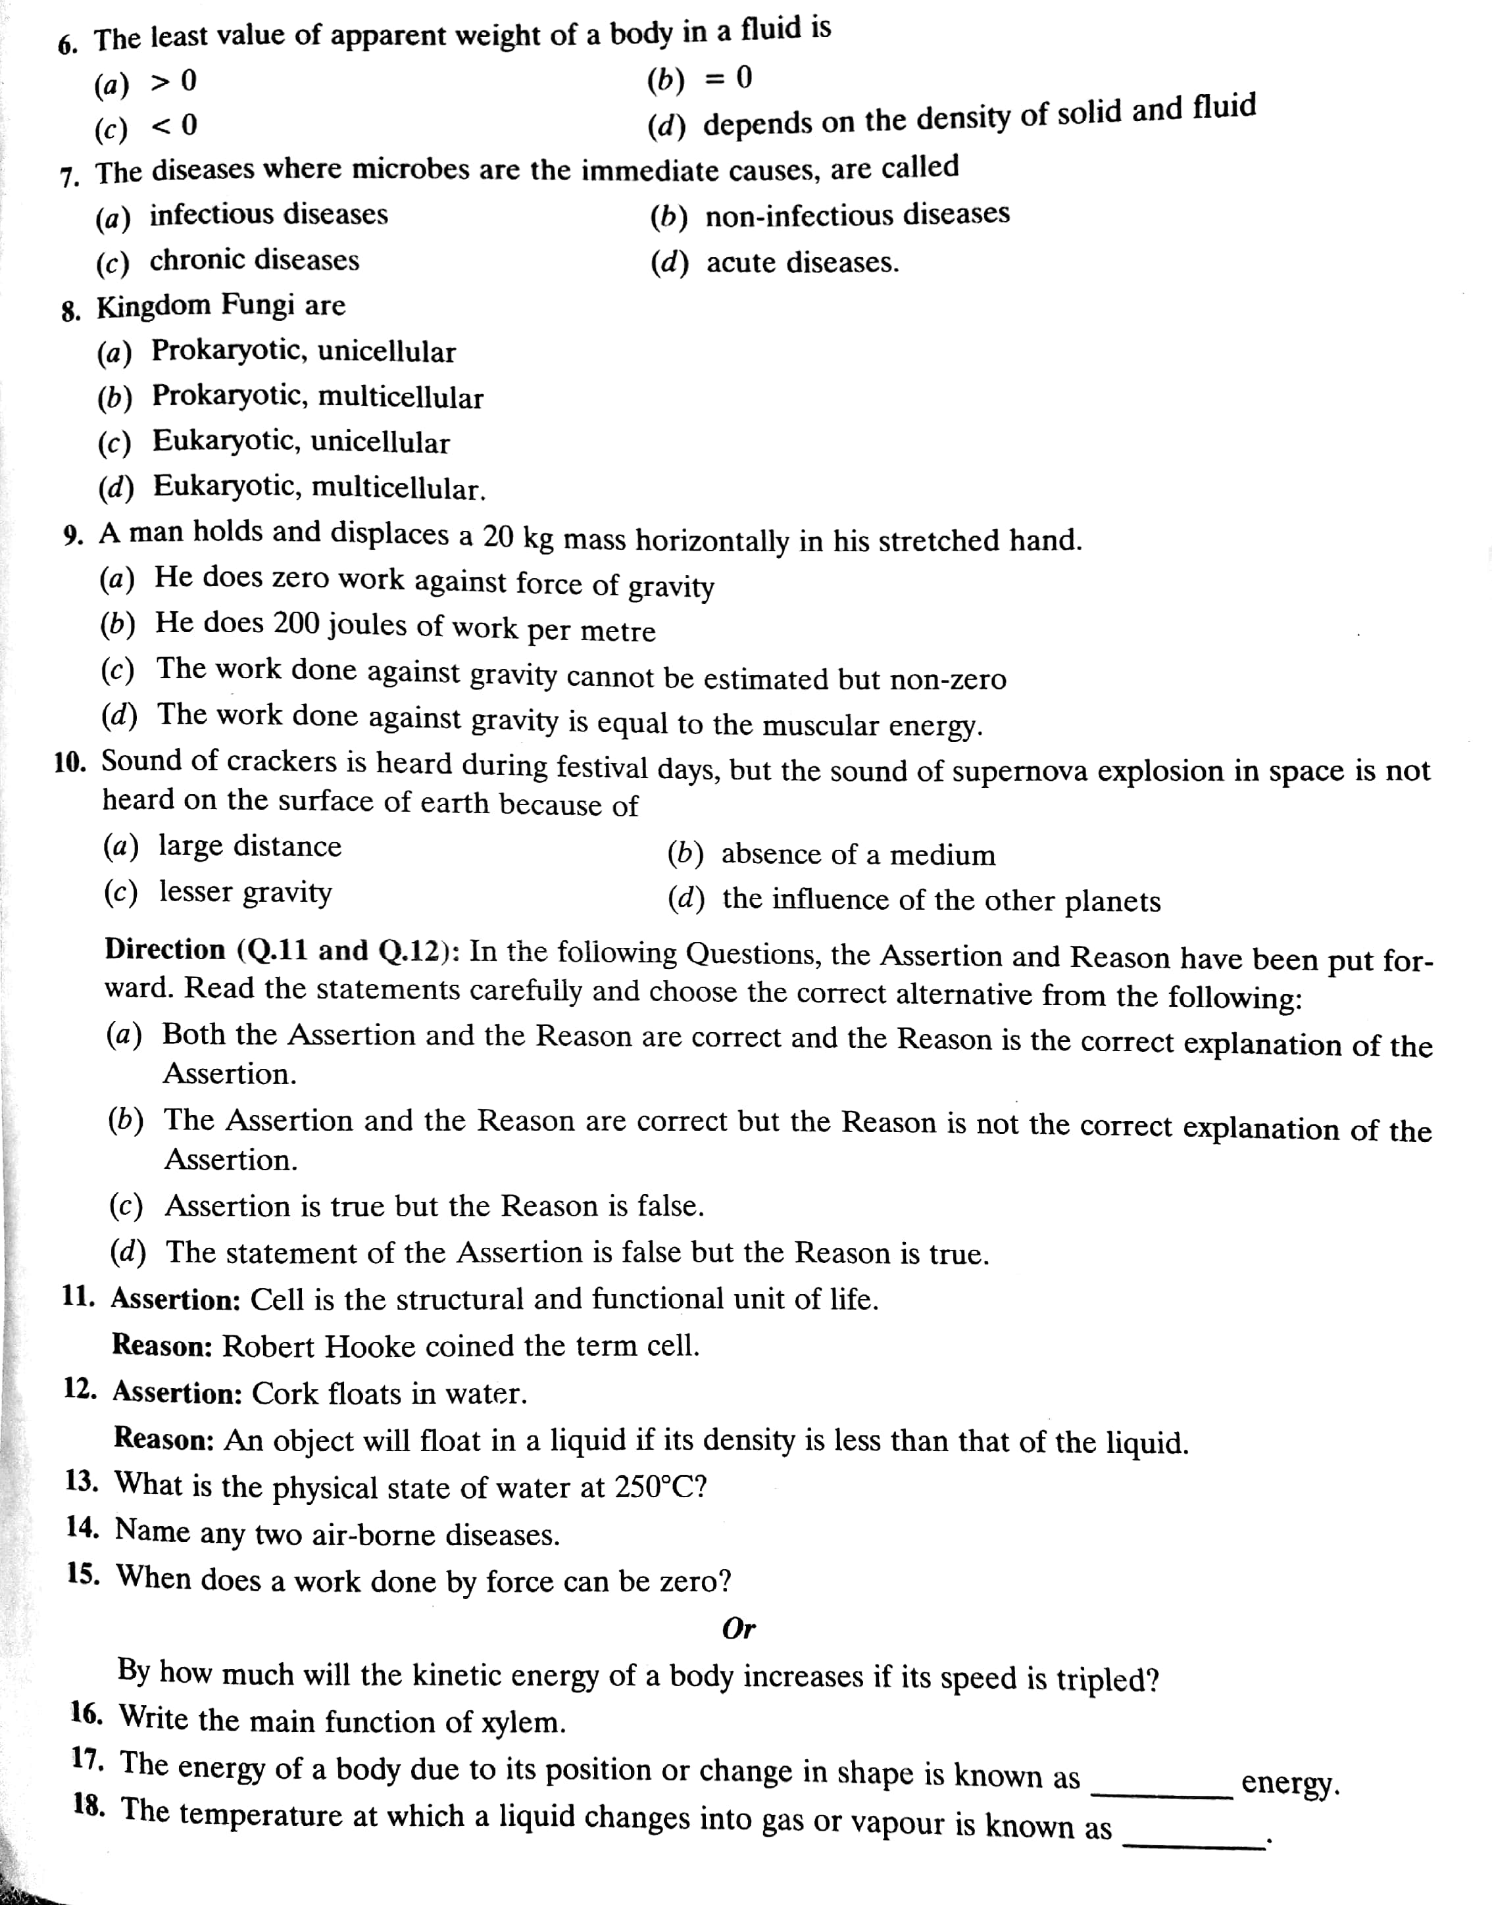

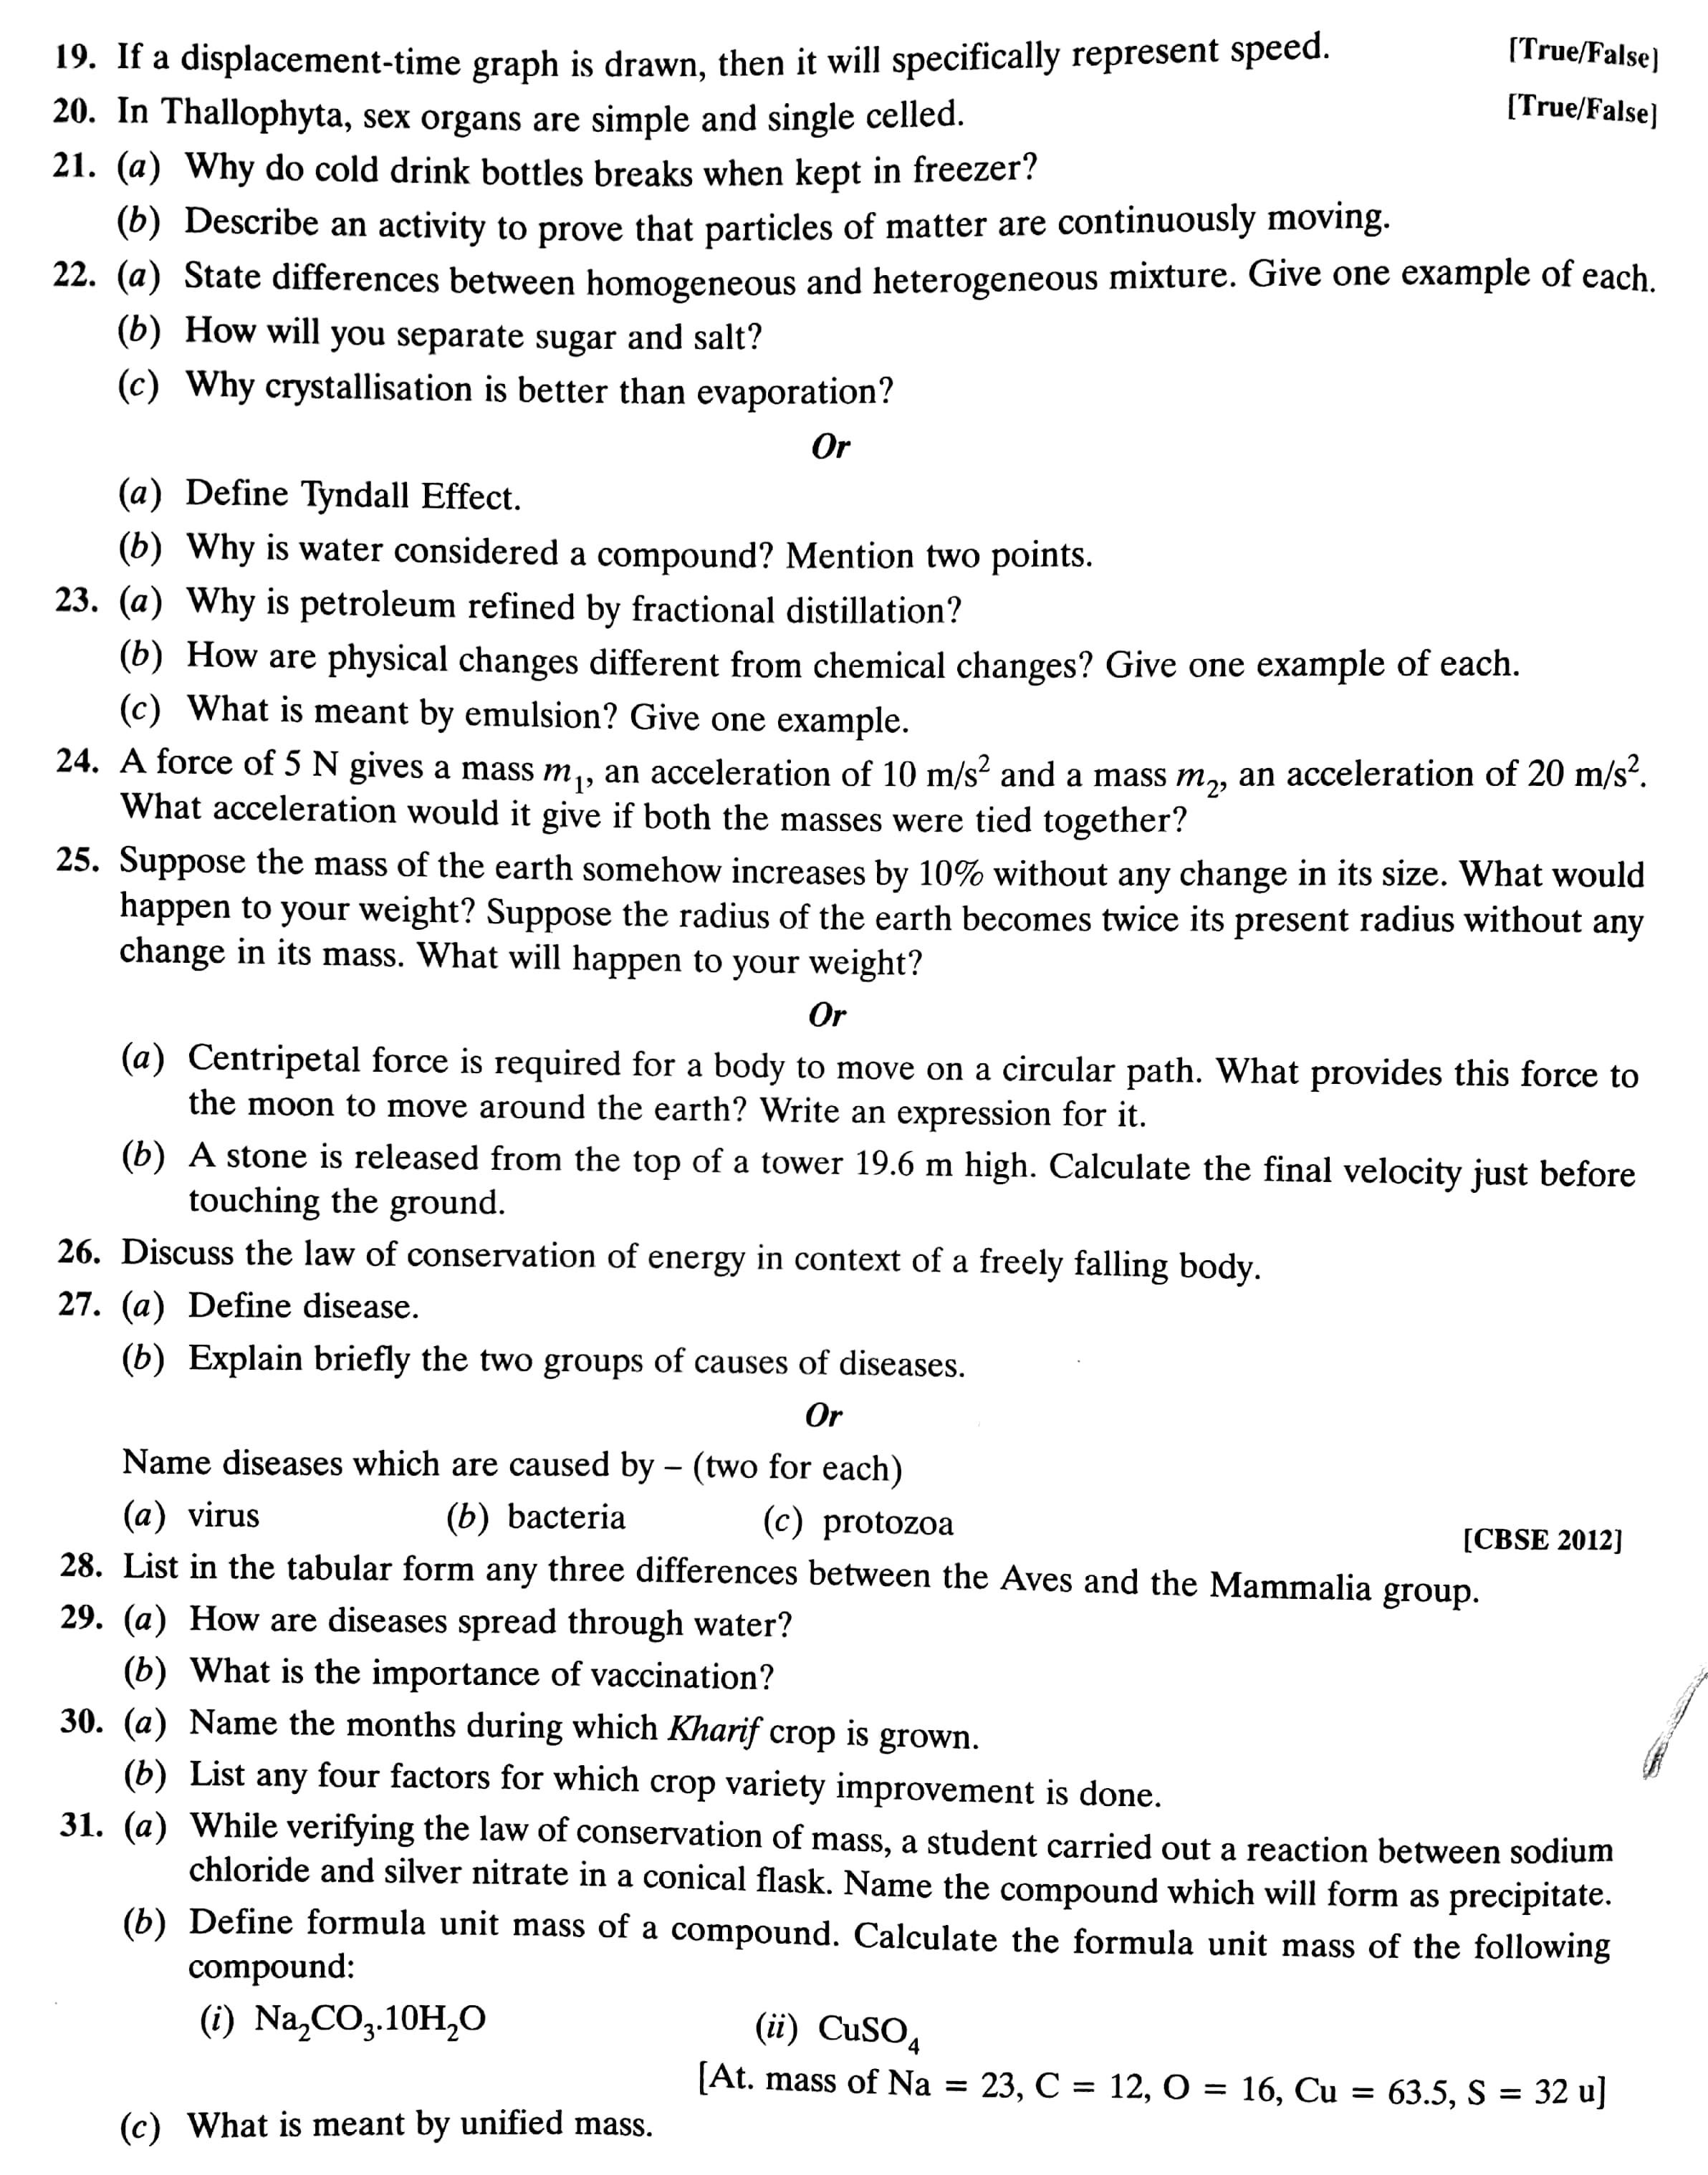**SECTION ( 3 X 10 = 30 MARKS)**

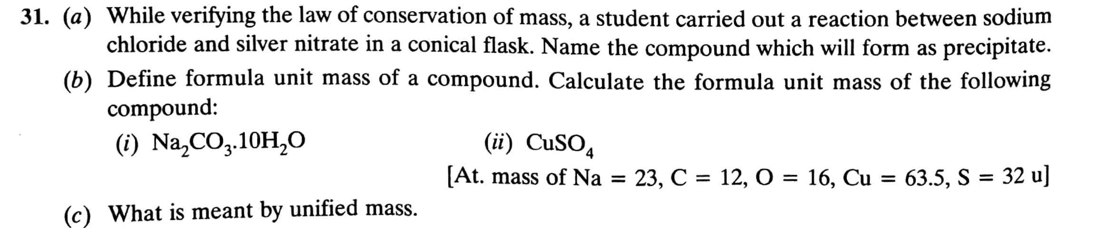**SECTION ( 3 X 10 = 30 MARKS)**

